Music Streaming Service

1. Creating the tables.

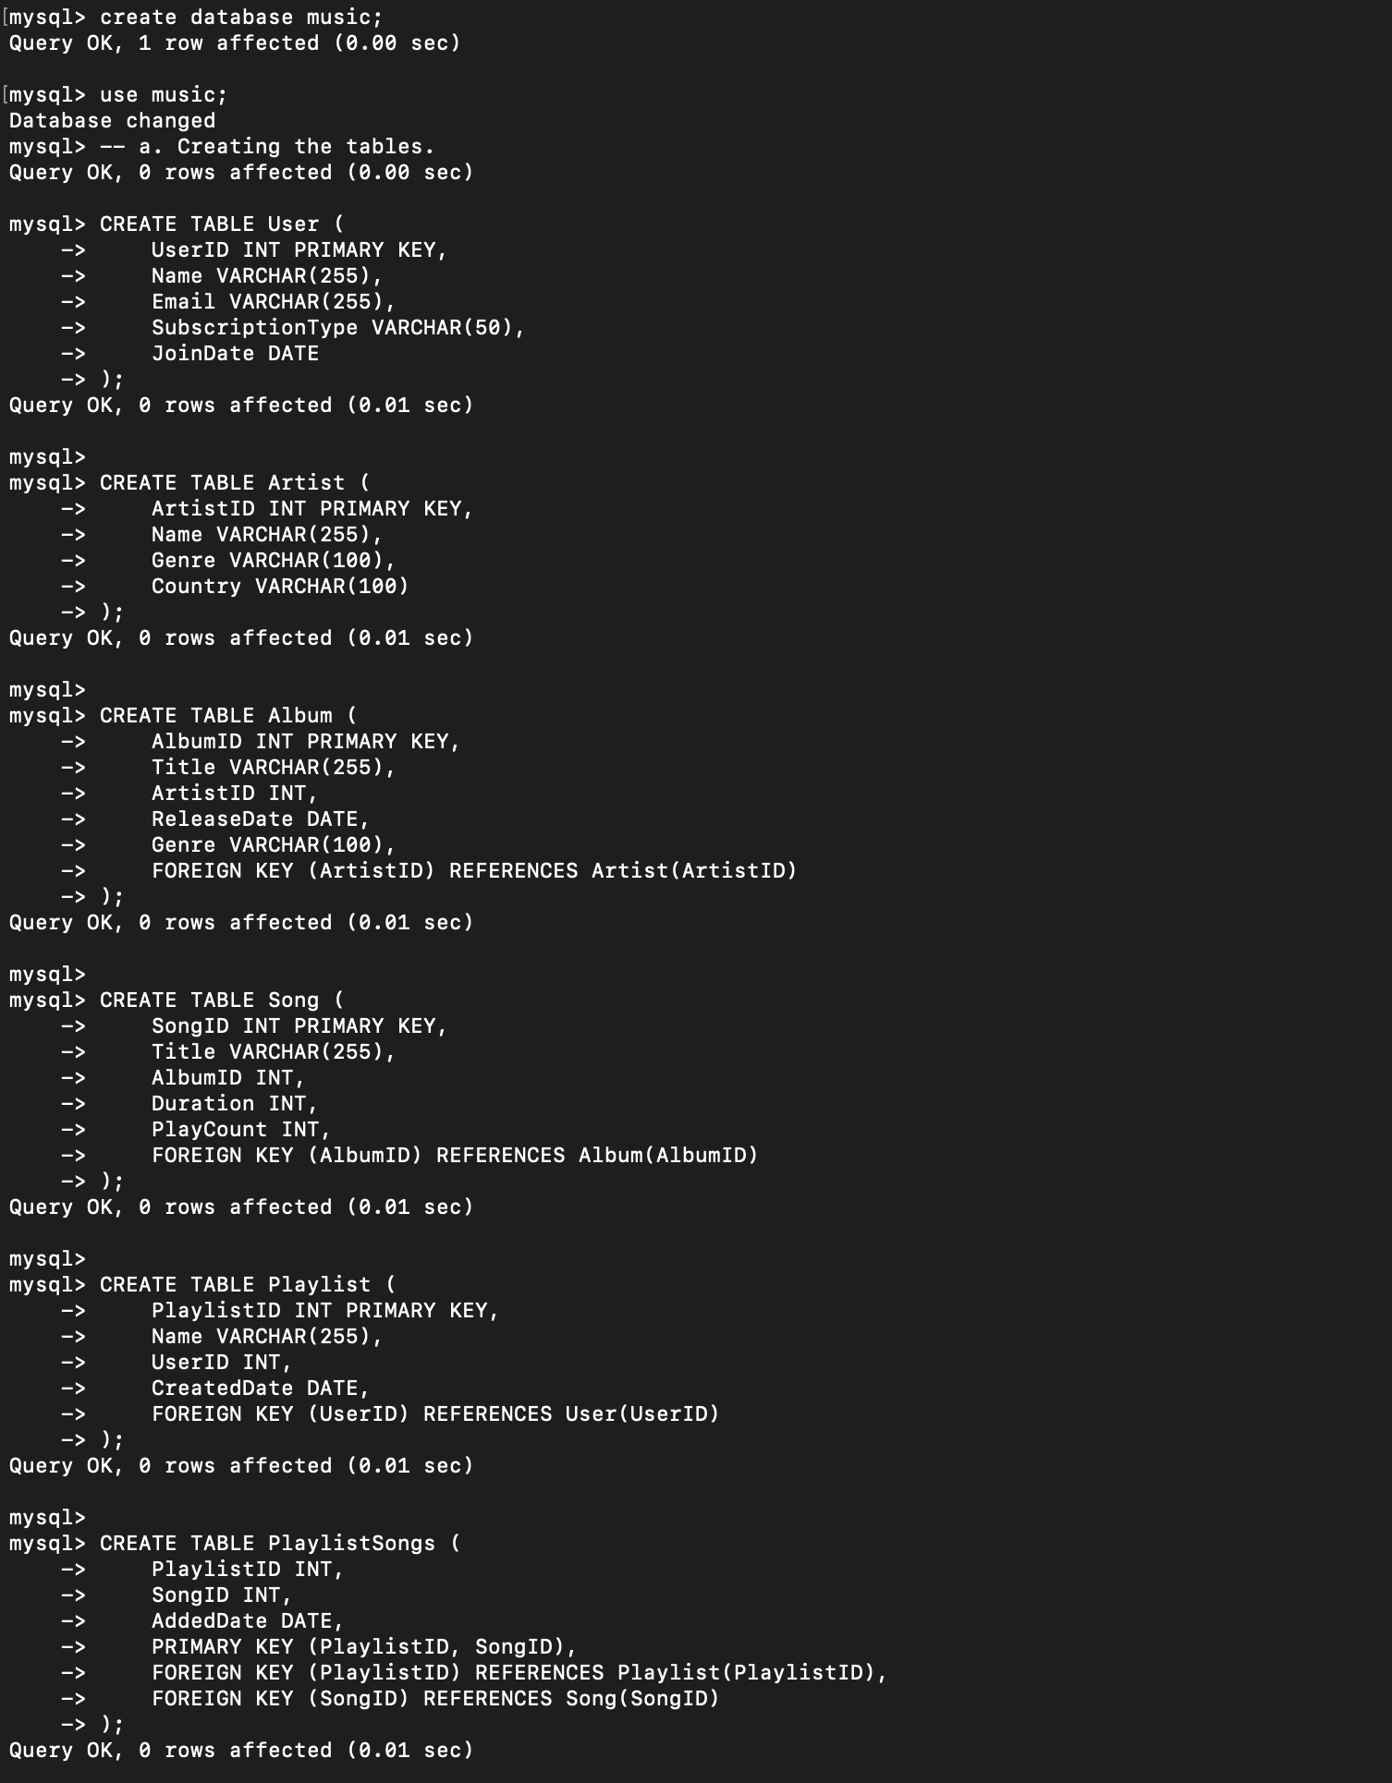

1. Inserting sample data.

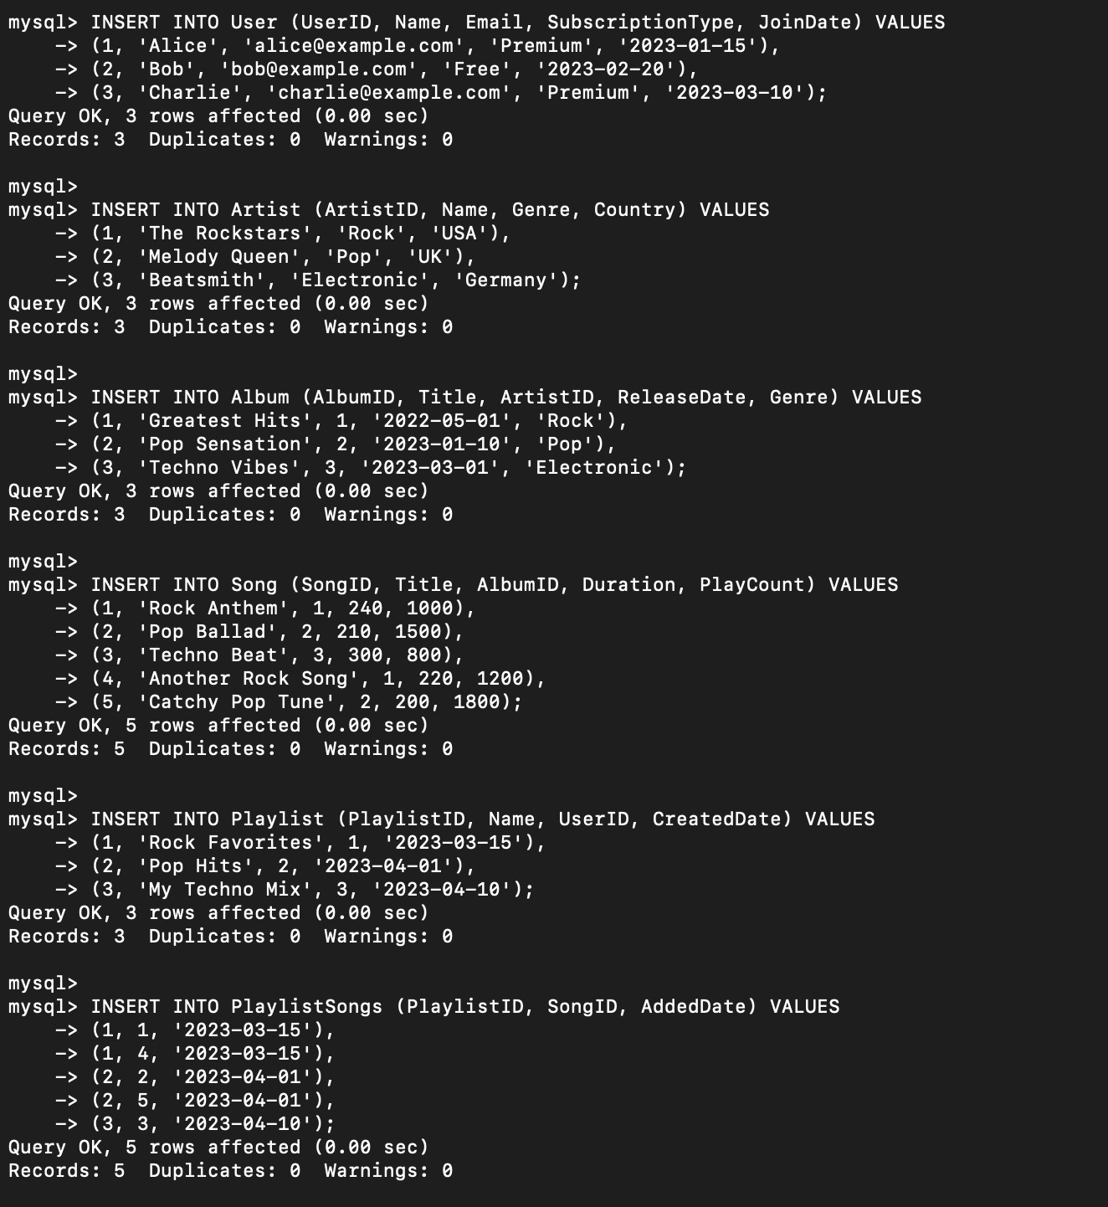

1. Retrieve the most played songs.

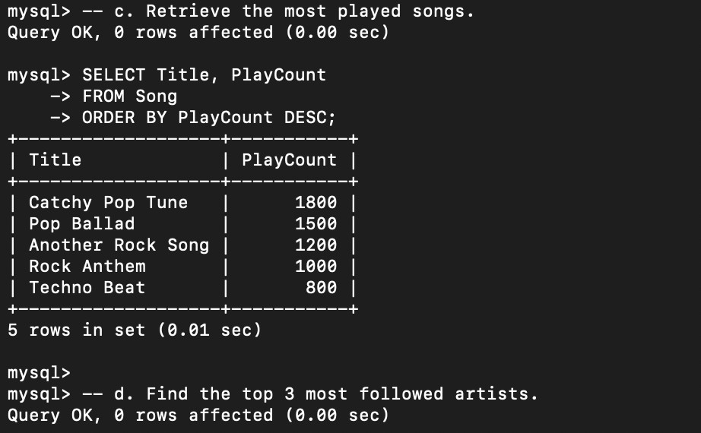

1. Find the top 3 most followed artists.

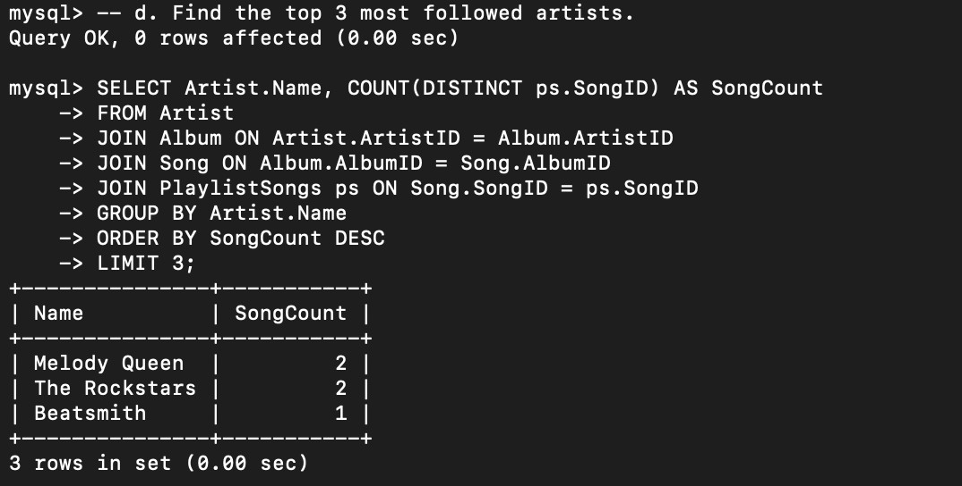

1. Display playlists created in the last month.

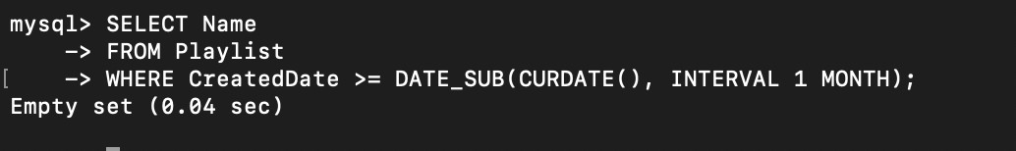

1. Retrieve total play count per album.

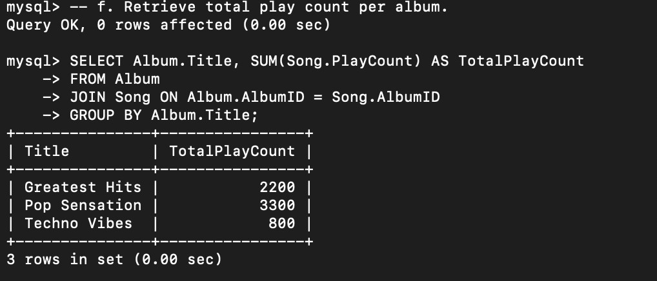

1. Find users with the most created playlists.

